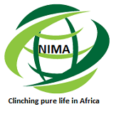

Nima East Africa Limited
nimaeastafrica@gmail.com
07 15 360479
020 7 865 581

Company Profile /Catalogue

BACKGROUND

Nima East Africa Limited is a locally registered private company based in Nairobi, Kenya.
It was incorporated on 24th November 2014, launched on 7th March 2015 at Kenyatta International Conference Centre (K.I.C.C) and its office officially opened on a prayer day under the leadership of our beloved Hon .Bishop .Dr. W. ABUKA. Hsc on 6th April 2015.

Nima East Africa Limited engages in the provision of a variety of Pest Control Services and Health Care Services and Products across East Africa.

GENERAL INFORMATION

Company Name: Nima East Africa Limited
Telephone No: +254 207 865 581
Cell/Mobile No: +254 715 360 479
Fax Line: +254 202 440 556
Postal Address: 67296-00200
E-Mai Address: nimaeastafrica@gmail.com
Website: www.nimahealthservices.com

Country of Ownership: Kenya
Year Established: 2014
Business Type: Distributor
Industry Focus: Home Healthcare Equipment, Laboratory Reagents, Equipment, Consultancy, All Pest Control Services, General Products and Services
Geographic Markets: Eastern Africa and the Horn of Africa.

GOAL
To be a company that provides exceptional clientele quality products and services.
VISION
Model of excellence in provision quality products and services.
MISSION
To promote health and reduce illness, ensure access to good and affordable products and services and pursue excellence in all spheres.

OBJECTIVES
- To Actualize the Kenyan Vision 2030.
- To improve the prosperity of all citizens in East Africa through economic development program, covering all the regions in East Africa.
- To build a just and cohesive society with social equity in a clean and secure environment. Nima East Africa Limited makes special provisions for citizens with various disabilities (PWDs) and marginalized communities.
- To realize a democratic political system founded on issue-based politics that respects the rule of law and protects the rights and freedom of every individual in East Africa society by setting an example for the rest to emulate.
CORE VALUES
- Customer:
Consistently meeting customer's expectations. Our purpose is to always see our clients happy.
- Botho:
Providing services with respect, kindness and in a friendly manner. We (as employees) shall serve all our clients with respect, kindness and in a friendly manner
- Timeliness:
Always delivering service on time. Our client will always receive services on time.
- Equity:
Equal service delivery to all, regardless of religion, social status and geographic location. All my clients are important, we (as employees) shall serve them equally regardless of their religion, geographic location, race or social status.
- Teamwork:
Working together for a common goal, appreciating weakness and strengths of others through shared efforts.

STRATEGY

We provide a broad spectrum of pest control services and healthcare solutions focused on the needs of our customers and designed to increase the efficiency of healthcare organizations and to eliminate limitations arising from poor access to medical facilities.

We provide value-added services such as initial consultations, training on the system upon delivery and management of annual reorder processes.

CLIENT BASE

We serve a wide range of clients covering commercial, research institutions, hospitals, laboratories and major hotels within East Africa.

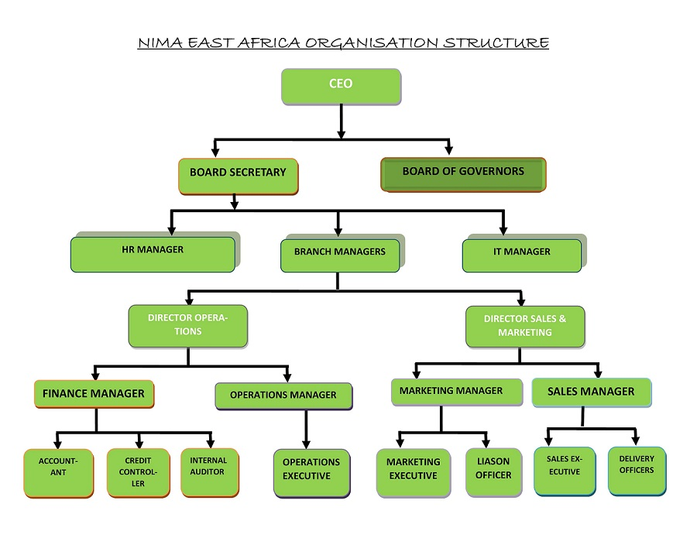

PRODUCTS AND SERVICES

We are engaged in the provision of a variety of Pest Control Services and Health Care Services and Products across East Africa as highlighted below:

  - Bedbugs
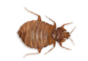
Bedbugs Control and Extermination Services Kenya
Preparation before bedbug’s fumigation and control in Kenya

Before a bedbug eradication process is done in your residential or commercial properties we ask our clients not to move any furniture or house hold items. All foods and food substances should be sealed and put at a central location and all electronic appliances should be switched off. We train with molecules of no color, no smell and non-carcinogenic with no skin irritation or sensitivity.

Our training involves marketing, entrepreneurship, appropriate protective essentials for all fumigation services, pest preventive, control and elimination mechanisms, life cycle of bedbugs and mode of action of recommended pesticides.

Professional/guaranteed bedbug control services
Nima East Africa Limited is Kenya’s guaranteed company for professional training services for absolute eradication of bedbugs in client’s commercial and residential premises across East Africa.
Bed bugs are sneaky and hard to find, but Nima East Africa Limited trains individuals to pinpoint evidence!

Bed bugs are capable of hiding so well and they also reproduce very quickly, this makes them very challenging to get rid of. Its egg stage is resistant to many forms of treatment. Our research has revealed that one bedbug produces five eggs per day which hatch within ten days and one bedbug can lay up to five hundred eggs in a life time. If you suspect you have bed bug infestation, the best and first action you need to take is to contact a professional pest control company where Nima East Africa Limited is leading to perform a thorough inspection and then recommend a bed bug control treatment.

Our experts will immediately do a very comprehensive inspection to identify if it’s really bed bugs infestation or other insect infestation, then give advice on the next cause of action. We won’t just inspect the beds, but also inspect other areas in your house where bed bugs are likely to infest. Thorough treatment will be carried out to exterminate the bed bugs and stop their spread and avoid infestation.

If bed bugs are found, Nima East Africa will create a customized bed bugs extermination that will not only treat bed bugs, but also help you develop a long term course of action to ensure future infestation is prevented. Proper bed bugs treatment needs a high level of expert service, it is an issue that can be dealt with, with the assistance of a pest specialist from Nima East Africa Limited.
If you feel like your health is being threatened by bed bug menace, contact Nima East Africa Limited. DO NOT let bed bugs ruin your health, regain the happy feeling of being safe and pest free in your home or office. Rely on trained professionals at all times at affordable costs only from Nima East Africa Limited.

What you need to know:

Bed Bug Facts
  - Bed bugs are small, oval insects that feed by sucking blood from humans. Bed bugs don't fly.
  - They carry human diseases such as plague, anthrax and typhus.
  - At room temperature, their eggs hatch within a week and ten days at lower temperatures.
  - Bed bugs mature fully within a month, producing multiple generations.
  - They are very resilient, nymphs and adults can take months without feeding.
  - Bed bugs are mainly active at night, they hide during the day.

Bed bugs are most active at night and may bite any exposed areas of your skin while you are asleep. The most common location for bed bug bites are face, neck, hands and arms. A bed bug bite is painless and is generally not noticed. The bites may most probably be mistaken for a rash. Its symptoms include; redness, swelling and itching.

Think you were bitten by bed bugs?

Where They Hide
Bed bugs can live anywhere in the house; they can hide in cracks, in furniture or in any type of textile. They are most common in beds, including the mattresses, box springs and bed frames. Other typical hiding places are;
  - Curtains
  - Beddings and nets
  - Clothing
  - Coffee tables (especially if bed bugs are found in a nearby sofa)
  - Luggage/handbags
  - Closet (particularly near the sleeping area).

What we can do to help! Bed bug eggs are delicate and resistant to many insecticides. Secondary infestations are common as eggs may hatch out after the initial infestation has been eliminated or dormant individuals may become active. This is why it is important to consult professionals trained by Nima East Africa Limited.

We are the giants in eradicating all bedbugs completely in beddings, furniture, bed frames, bed sheets and electronic appliances, bedbugs are also transmitted through luggage’s ,public transport, hotels, public vehicles if you notice signs of this pest which usually are bloody stains in sheets contact our Nima East Africa Limited for bed bug control experts.

These bugs multiply quickly i.e. one lays about five eggs per day ant almost all the eggs hatch within ten days. However Nima East Africa Limited eradicates bedbugs completely in all stages from the eggs within one hour using modern products and services recommended by Pest Control Products Board and W.H.O.
The public is therefore advised to prevent an infestation by contacting our expert services immediately to offer an inspection whereby we will examine you commercial or residential premises including the beddings, bed frames carpet, to target breeding areas we start with their most common habitat which is the bed room and all over your home and commons signs of an infestation are alive or dead bedbugs, small reddish brown spots, faecal spots and tiny white eggs.

After a professional assessment of client's home our exterminators will determine the best course of action which includes bedbug’s preventive services and bedbugs curative services.

Roaches and Cockroaches

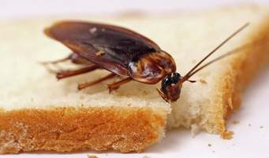
Roaches control and extermination

We are also Kenya’s leading trainers in cockroach control services and roaches extermination services, roaches eradication, cockroach elimination and leading cockroach solution in Nairobi Kenya.

Nima East Africa Limited provides our guaranteed cockroach control services, cockroach extermination services, cockroach elimination services and are proud to cover cockroach control services in Mombasa, cockroaches control services in Nairobi.

Cockroaches can bring havoc in your home and are a nuisance pest to have both in your commercial or residential properties we do cockroaches control, cockroaches extermination, cockroaches elimination, cockroaches eradication, in your premises and this are the assured measures for pest control across East Africa

Roaches are known to carry various diseases this is because they habitat near waste grounds and are found in the kitchen this is their main breeding grounds we offer professional cockroach control in residential ,commercial, offices and industries. Our experts advise the clients on how to deal with a cockroach infestation and offer recommendation for all Kenya cockroaches’ extermination solutions.

Cockroach Control in Kenya
We are the experts who make experts and lead the leaders!!

Cockroaches are common in homes because they prefer warm environments close to food and water. They can cause allergies, and track a lot of bacteria and germs into our homes. They also trigger asthma attacks especially in children. Cockroach infestation can be very dangerous especially to children. Cockroaches are very common insects infesting several homes, restaurants, hotels, and learning institutions. Cockroaches are repulsive and objectionable to most people simply by their presence.

Our Recommendation
Nima East Africa Limited recommends that;
• Sanitation is an important step in prevention and control
• Empty soft drink bottles
• Cardboard boxes must be cleaned
• Paper bags should not be allowed to accumulate
• Any food container must be sealed and crumbs cleaned up.

Roaches control in Kenya is complex this is because of the many occurring roaches’ species which are around. We are the trusted company in Kenya to provide total cockroaches control, fumigation, extermination, and prevention and elimination services for homes.

German Cockroaches

This roaches are usually indoors and are light brown in color with stripes. Adults have wings and do not fly and prefer to run, they live in warm humid areas and infest your kitchen and washrooms they feed on any food available in your home thus enabling them to reproduce quickly after mating. This pest is commonly found in the kitchen, computer, and electronic appliances like micro wave and fridge.

America cockroach
Adults are more than 3 inches long and reddish brown in colure with a yellow band outlined behind their heads. This species are fond of abundantly existing in great numbers in the kitchen and where food is stored. Nima East Africa Limited professional cockroaches control experts will solve your problem quickly and effectively both in residential and commercial properties.

Australian cockroach
Australian Cockroach Identification:
The Australian cockroach is reddish brown and looks similar to American cockroach but is smaller at 1.25 inches (35mm) in body length. The Australian cockroach has yellow strips on the outer edge of the front wings. It is a world-wide species that prefers a vegetarian diet known to eat holes in clothing and even book covers.

Madagascar hissing cockroach
This roaches are also referred to as hissing cockroaches or giant roaches and are 7.5 cm in length and are the largest cockroach species. When disturbed this pest will produces a hissing sound to communicate with the rest of the colonies or to chase away predators. All residents and institutions are recommended to engage pest control officers in Nima East Africa Limited to enjoy a pest free environment by keeping larvae and eggs totally exterminated.

We have many years’ experience in control of cockroaches our experts will detect the slightest problem because we use the latest pest control products in the market to tackle your infestation.

Preparation before cockroach fumigation
Before a cockroach fumigation process is done in your residential or commercial properties we ask our clients not to move any furniture or house hold items. Food should be sealed and put at a central location and all electronic appliances should be switched off.

  - Flies
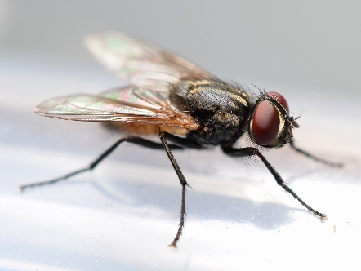
Flies are associated with more than 100 pathogens. These pathogens cause diseases in humans and animals. Sanitation is critical to controlling these pests, but accurate identification is essential for successful fly control. Flies collect pathogens on their legs and mouths when they feed on waste, these pathogen are transferred to our foods and tables when they land on them. It is therefore essential that cleanliness is maintained at home in order to control houseflies.
Prevention

  - Flies prefer warm temperatures and are most active from late spring to early autumn. In order to best repel flies during this time, limit access to your home as much as possible, keeping doors and windows closed.
  - Keep garbage cans clean and covered at all times.

Nima Fly Control
  - Professional experts will always conduct an inspection to determine the house fly species they are dealing with.
  - The experts will then locate the breeding sites and treat the area with residual fly control.
  - Nima East Africa Limited experts will then get rid of the adult house fly using the most suitable method depending on the situation

Flea
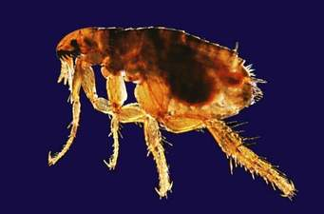
Flea Control
Nima East Africa Limited is the number one spot in profound trainings on all crawling insects and flea control and extermination services in diverse place across East Africa remains remarkable in Kenya.

Fleas are reddish brown in color and are wingless covered with hair on their bodies. They are usually fed on feaces and drain blood from their hosts. They feed on hairy animals such as dogs, cats, mice’s, chicken and other domestic animals.

This pest usually jumps since it lacks wings. They may cause skin allergies once bitten by them. To easily control and eliminate fleas, it is important to target them at adult stage since adult fleas are easy to locate.
Nima East Africa Limited flea control team has experts who will provide the latest innovation and solution to totally exterminate your infestation be it your homes, residential and commercial properties. Do not hesitate call us now and make a booking.
Nima East Africa Limited is one of Kenya’s leading mosquito control service company offering guaranteed services to all our clients in residential and commercial properties.
We also offer mosquito FAQS, malaria control strategies and control in Kenya.
This pest feeds on warm blooded animals and human to reproduce. They are common in urban areas, and are a nuisance and stressful. A bite by mosquitoes is dangerous because they transmit diseases like malaria, yellow fever, blue tongue and many more.

These pests are attracted by scents, sight and heat. They breed where stagnant water is and reproduce quickly. Nima East Africa Limited mosquitoes control experts offer lasting solutions.

Mosquito
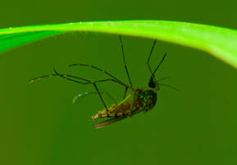
Mosquito Control
Mosquitoes need quick response and eradication because they are a nuisance and a health threat. It is therefore important to eradicate mosquito infestation around your premises and other living recreational areas such as hotels and restaurants.

Mosquito Eggs
Mosquitoes normally lay their eggs in water and they do not need much water to produce their eggs, a small amount of water is enough to support mosquito breeding.

Nima East Africa Limited Recommendation
  - Maintain your swimming pool regularly to prevent mosquito breeding.
  - Wipe out your bathroom every week. Eggs could get stuck to the bottom and survive
  - Remove any puddles of water around your home to reduce mosquito breeding sites.
  - Dispose or puncture unusable tires to prevent pools of water from forming inside them.

Adult Mosquitoes
- Keep grass and shrubs trimmed short, this will possibly reduce places for flying mosquitoes to rest.
- Make sure doors and windows are in working order, leaving them open makes it easy for mosquitoes to fly in.
- Consider using pesticides for treatment. Make sure to select specific products for controlling mosquitoes or contact Nima East Africa Limited for inquiries.

Professional Treatment
To deal with mosquitoes we first locate the source and deal with it. We use effective products designed to be applied directly to water to control mosquito larvae. Our mosquito control is accomplished by doing the following;
  - Eliminating mosquito breeding sites
  - Getting rid of adult mosquitoes
  - Using mosquito repellent products

We use residual insecticides spray to eradicate mosquitoes. Many species of adult mosquitoes are found resting during the day. To solve this, professionals will spray the bushes, grass, shaded areas and flowers around the premises. Our residual insecticide for mosquitoes control is safe and very effective protecting treated environment for at least 10 months.

Rats and mice control in Kenya
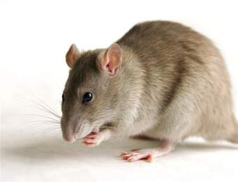
Nima East Africa Limited extravagantly trains individuals on Rodents and Rats control services. We offer all professional Rodent pest control services with a guarantee.
Our rat and mice extermination, elimination services for our clients both residential and commercial properties. We offer fumigation and pest control services for residential and commercial customers within East Africa.

Rat and Mice Control
Rats are very troublesome and very damaging. They eat and contaminate food, damage structures and property, and transmit parasites and diseases to other animals and humans. Rats are mostly found in homes where there is easy access of food. They are also found in buildings, farms, gardens and open fields

Rat and Mice Prevention
  - Check for holes or gaps in the house and repair them using rodent proof material.
  - Keep garbage cans covered at all times
  - Get rid of all left over foods immediately because they will attract rats.
  - Ensure your house is clean at all times
  - Do not leave food open for long periods as this will give opportunity for rats to feed.

Rat Control
The following are steps Nima East Africa Limited uses to get rid of rats and mice.

  - Nima East Africa Limited experts will conduct an extensive inspection especially in the kitchen to determine their hiding spots.
  - We will recommend the appropriate control measure to take.
  - Our experts will then set up baits and put up control measures to lure the rats to the bait.
  - We will also spray infected areas to protect and get rid of future rodent infestation.
  - A follow up inspection will be done to ensure that all the rats have been eliminated.

For our Kenya clients in residential and commercial premises, we offer rat and mice elimination, extermination and rodent control. This is because they are small pests which are a nuisance and if not controlled can infest your premises quickly especially in the presence of food to feed on. Our guaranteed rodent control in Kenya uses strategic methods to get rid of rats and mice by using Baits traps for total extermination.

This pest can squeeze through spaces because of their body size. Our experts cave these holes to prevent mice infestation. We provide preventive and curative methods through a detailed inspection of your premises. Nima East Africa Limited will provide consultation to know how to tackle your infestation using human friendly chemicals which are non-toxic and eco-friendly to children and pets as well. We ensure our clients are completely satisfied.

Spiders
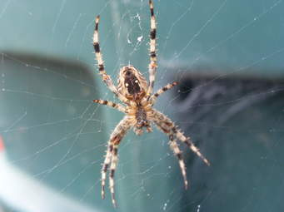
We offer spiders control services within East Africa. This pest is very harmful and requires professional eradication since its venom is very dangerous.

There are so many species all around the world but Kenya has mainly two types of spiders in our structures and households:

- Black widow which is most recognized by the red hourglass shape under the abdomen
- Brown Recluse which have brown violin marking on their back

It is very important to eliminate the spiders since if bitten by one, a person can end up in the hospital, and therefore, Nima East Africa Limited offers the best solution to this type of pest elimination and control of further infestation.

Bees
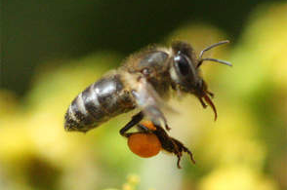
Bees are beneficial for commercial purposes and an important part of our ecological system but endangers individuals who are not well trained to handle them therefore we offer professional services to control and eliminate them.
We determine and identify whether actually the infestation is high or low, this is to determine how to eliminate the whole nest without causing harm to the households.
Bees in the established nest require dire desire for extermination before they cause serious destruction to the client’s premises. We do advise that however small the infestation, it is very important to eradicate the infestation before it gets out of hand.

Ants
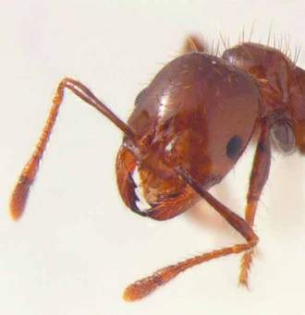
Nima East Africa Limited is the leading pest control/fumigation service provider exterminating and controlling ants in East Africa. For assured service provision against ants call us .We offer professional and well organized extermination to the ants infested areas.

Ant Infestation
Ants come into our houses seeking water and sweet or greasy food substances. They can enter the house through the tiniest crack available, they leave a chemical trail behind which contains pheromones for others to follow once they locate a food source.
Heavy ant infestations should always be controlled by pest specialists. If an outbreaks keep increasing, it is a sign that everything is not working. Nima East Africa Limited is your best source for both effective treatment and prevention of future infestation.

There are so many species all over the world, but in Kenya we have two types of ants foraging our households:

Garden Ants
They are attract to sweet foods and leave trails back to their nest for other ants to follow to the food source and increase the infestation.

Pharaoh Ants
They originate mainly in the tropics and require artificial heat to survive and reproduce and mostly tend to live in huge buildings such as hospitals, hotels and big flats. Mostly they feed on food stuff and germs.
It’s advisable to control ants by eradicating them you leave everything in the house as it is so that most of their nest are not destroyed or make them infest another part of the house in the process, we require our clients to contacts as early as they notice any infestation in the building.

We require the households to remain untouched so that the nest are set up and eradicated from the queen to all the other ant colonies. We offer professional pest control services with our well trained and equipped technicians with the right pesticide.
Nima East Africa Limited Fumigation services understands the routine of each species and also have a range of powerful pesticides to deal with the pest and come up with a solution to fully eradicate and prevent any further infestation.

Ants Food
Prevention and Control
  - Ants get attracted to food sources, therefore ensure your house is clean, especially the kitchen. Ensure that attracting food substances are covered tightly.
  - Sweep the floor after meals because even the tiniest food substances can attract ants.
  - Always ensure food that is not in the fridge is covered.
  - Avoid leaving dirty dishes in the sink
  - Always empty the trash regularly
  - Ensure to keep the trash cans far from your house.
  - Always keep the house dry, because ants will always be looking for a source of water and stay near it.

Ant Control
It can be quite difficult to control ants without knowing the kind of ants you are dealing with, one has to correctly identify the species of the ant troubling them. Nima East Africa Limited has the expertise to deal with ant infestation. A thorough inspection will have to be done by our experts so as to know the extent of the ants in the house. The experts will also determine the species of the ant in order to come with the right control mechanism or the type of bait to use on them.
We use baits to control ants, ants baits are a very successful method of controlling ants menace. They are safe to use around pets and children. Ant baits come in gels, granules or stations, active ingredients in these baits are sugar based to lure a variety of ant species and target their dietary needs.

Termites
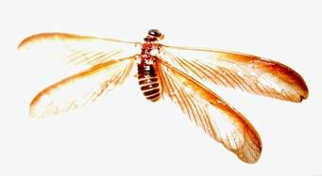
Termites are mostly confused with ants; this confusion has cost property owners a lot because of their sizes. They can easily be mistaken for one another from a far, but if you look closely, you would notice that termites have a pale or white color, straight and beaded antennas.

Termites Entry Point
Termites normally thrive underground, they often enter premises below or at a ground level, making wood to ground contact. Like porch steps, door frames a common entry point, holes, and cracks in walls.
Termites are used to travelling through to foundations and other wooden parts of the house. They build mud tubes from the soil up to keep their soft bodies from dehydration until they get into contact with wood.

Treatment
After inspection, trained experts will apply termite treatment options- which is chemical treatment that is applied to affected areas and the surrounding in order to keep the termites away. Our treatment normally comes in two varieties which are repellent and non-repellent methods. Treatment is also applied to the siding and sheet rock of the house in order to further prevent any termites from setting within the structure.
We normally recommend immediate follow-ups on a weekly basis to make sure the infestation is purely eradicated. Generally there will be no visible signs that the home is infested.
Infestations can go undetected for months, hidden behind walls, floor coverings and other obstructions. Termite feeding and damage can progress undetected in the wood that is exposed because the outer surface is usually left intact.
Ants are a nuisance when they invade your household’s structures mostly wooden areas. They require general elimination. We recommend an earlier preparation is required in the house majorly in the kitchen areas mostly because the food dropping and the weak rotten wooden carvings.

Bats
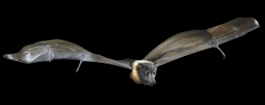
We offer professional bats control for residential and commercial clients in East Africa. We are the leading and most trusted service provider, guaranteed with safe removal. Nima East Africa Limited pest control services provide a total extermination of bats using modern products and techniques.
Bats are nocturnal flying mammals that leave their perch areas to feed and then get back to sleep. Most species are common during warmer season and hibernate during cold seasons.
Bats can pose a serious threat of health if they are found inside the houses. The fungi found in their droppings cause lung diseases. Nima East Africa Limited professionally clears the droppings, disinfects and removes due to the vulnerability of the inhabitants of the households.

Bats have some colonies which are infested with rabies and may not show symptoms at all. Rabies can be transmitted through body tissues or any contact with saliva from the bats on any animal. For that reason we do advise that it’s important to seek medical attention if in any chance one must have had contact with the bat infested area.

Bat infestation usually calls for households to choose for their houses to be controlled the infestation gets out of hand. Bats should be controlled without harming them because we value their environmental sustainability and maintenance.

Nima East Africa Limited customizes all the infested households and human structures with great bat and human structures with great bat elimination services both in and out of the building.

We value our customer satisfaction therefore we do what it takes to professionally eradicate the pest from the premises completely.

Moths
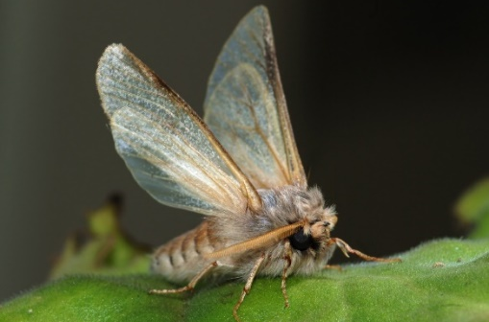
Nima East Africa Limited offers professional services in eradicating moths. This type of pest mostly depend on their species and with that its high infestation is detected when they destroy fabrics, leave webbing or cocoons and even droppings.
We use the right pesticide to eliminate the swarm before it gets out of hand, it is also advisable to determine the moth and breeding sites.
When you notice any infestation of moth pests, contacts us in time before they become destructive.

Snakes
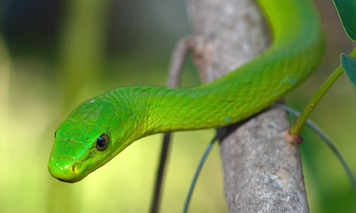
Protecting you and your family from snakes
Snakes – and the risk of Snake Bites – are a real threat to people living in Kenya.
Most snakes are extremely timid creatures and are only likely to attack if cornered or provoked as attack is, in most instances, simply a form of defense.
The required treatment for a Snake Bite varies from species to species and being able to identify the species of snake that has bitten someone is an important part of the procedure. You can learn more about some of Kenya’s more common snakes in our Pest Control lectures.

Be aware of the dangers posed by snakes and take steps to avoid them:
Snake bites caused by accidentally stepping on to a snake- especially if you are out walking in grassland or the bush - are nearly impossible to predict or prevent but by taking a few simple, but sensible precautions you can reduce the risk.
- When walking around make plenty of noise to advertise your presence which will most likely cause the snake to move away.
- Wear strong boots or shoes and long trousers when walking in grassland
- NEVER walk about barefoot – especially at night!
- Avoid long grass and stick to paths and tracks as much as possible
- Use a long stick to ‘probe’ the ground ahead of you; be aware that snakes can ‘play dead’ so do not attempt to touch a snake that appears dead.
- Walk in single file through long grass or the bush.
- Climb on to large rocks or logs in the pathway and step off them on to clear ground; these are favorite haunts for snakes.
- Watch where you put your hands and NEVER put them down a hole.
- Do not attempt to catch, kill or corner a snake.
- Use a mosquito net at night and tuck it in tightly.
- Never sleep on the ground unless you have a tent with an attached and built in ground sheet.
- Always use a torch to light the ground ahead of you at night.
- If you see a snake stand absolutely still and then slowly back away; remember that many snakes can strike up to half their length.
- When entering garages, sheds, storerooms and other outbuildings open the door, light the internal area and visually check for snakes remembering that you will, in all likelihood, be blocking their exit and that this is when they can attack in defense.

Minimize the risks of snakes living in your garden
Before looking at ways to prevent snakes getting in to your house you should ensure that your garden is not a haven for snakes to take up residence because they would then be much more likely to make their way into your house, garage or any outbuildings you may have.
- Long Grass is a favoured habitat of snakes so keep yours well mown.
- Keep shrubs trimmed round their base and away from the house.
- Ensure that branches of trees do not overhang your house or seating areas in your garden.
- Stack your wood on a suitable platform – such as a pallet – off the ground.
- Regularly sweep up leaves and other garden debris.
- Fill gaps, cracks and crevices in brick and stone walls.
- Wooden decking in seating areas should be solid, rather than slatted, to prevent snakes climbing through it.
- Be aware that play areas such as Wendy houses, Tree houses, sand pits etc are potential harborages’ for snakes.
- Compost heaps could potentially attract many different species of wildlife which, in turn, may become the prey of a snake.
- Ensure that your compost is made in a sealed and sold structure, preferably raised off the ground, and can be securely sealed against any wildlife but particularly rodents.

‘PROOF’ YOUR HOUSE AGAINST SNAKES
How ‘snake proof’ is your house? Are you aware that a snake, particularly the thinner ones, can get in to your home through a gap the size of a biro or pencil – as can a mouse! Also remember that snakes can swim and climb so carefully inspect your house, garage and all outbuildings.
Nima East Africa Limited can survey your premises and advise you on proofing against entry by snakes – and rodents.
What to look for when inspecting your property:
- Do you have screens on your windows and doors? Are there gaps around the frame or holes in the actual screening?
- Do you have gaps under doors in & out of the house, garage doors, shed doors? If so, bristle or sealing strip can be an effective way to seal these.
- Are there are holes, cracks or crevices in the brick or plaster work of your house?
- Are there any holes, cracks and crevices between patio areas or pathways and your house?
- Drainage areas in patios are a perfect point of entry.
- Is the gauge size of any grates covering your drains small enough to stop snakes going down it?
- Make sure that there are no holes in your roof that snakes can get through - particularly if trees overhang your house.
- Ensure Skirting boards do not have gaps under or behind them
- Seal all holes where wiring, plumbing or gas enters your home
- Cover gutters and drain pipes with fine gauge mesh
- If your home has wooden floorboards ensure that access to the floor space beneath them is sealed and that gaps between the boards themselves are filled.

N/B:

All Price Quotations Can Only Be Made Upon Inspections And Assessment Of The Extent Of Infestation Of The Premise.

BUDGET

ksh. 5,500 monthly training fee for six months (paid six times)
ksh. 10,000 for protective gears (paid once)

OTHER SERVICES

- Cockroaches Elimination
- Bedbugs Elimination
- Bats Control & Removal
- Termites Extermination
- Bees Removal
- Fleas Extermination Services
- Rats, Mice Control
- Wasps & Spiders Removal
- Mosquitoes Control
- General Pests Inspections
- Bird Control
- Feral Cats Control
- General Reptile Control
- Bird Mites Removal
- Dust Mites Elimination

HOSPITAL PRODUCTS AND SERVICES

- Point Of Care Laboratory tests
  - Diabetes- Profile, HbA/C, Hb
  - Hepatitis
  - Hormonal Serology
  - Malaria
- Syphilis
  - Direct Antigen Tests(Stool) for Helicobacter Pylori
  - Antibody Screening tests for Helicobacter Pylori
  - Salmonella Ag Test (Stool)
  - Adeno-Rotavirus Screening tests
  - No diet restricted Fecal Occult Blood
  - Rheumatoid Serology
  - Streptococcal Serology
  - C-Reactive proteins
  - Pregnancy tests
  - Tumor markers

- Microbiology,
- Culture Media
- Growth Supplements
- Biochemical Tests
- Antibiotics Sensitivity discs
- MIC,(ETEST)
- Anaerobic Bacteriology(jars) and gas generating Sachets, (Carbon dioxide, Microaerophilic)
- Stains (FDA or EU approved)
- Blood Culture (Adult and Paediatric)

- Clinical Chemistry:
- Calometric and Kinetic Ready to use Liquid Reagents
- Normal and Abnormal Controls
- Standards and Calibrators

- Histopathology & Cytology:
- Complete Pap Smear Collection kits (with Speculum, slides, brush)
- FDA, EU approved Histology & Cytology Stains
- Rapid Urease tests from gastric biopsy

- Reproductive Health:
- Vital Screen (Vitality Stain)
- Sperma Stain (Morphology Stain)
- Leuco screen (Leucocytes Staining method)
- Sill-Select Plus (Sperm preparation kit)
- Sperm Freeze
- Fertility Score kit (tests for male fertility potential)
- Hypo-osmotic Swelling tests (Sperm vitality test)
- Episcreen (Alpha-glycosidase determination kit)
- Sperms TMG (Detection of Sperm antibodies) IgA and IgG
- Fructose tests
- Citric Acid Tests

- Consultancy
- Good Laboratory Practice (GLP) and Laboratory Management.
- Sourcing of Laboratory products (International Tenders)
- Laboratory Design and Business Plan

- General Supplies

- General goods services
- Stationary and ICT products
- Stationary and ICT products
- Event Planning and management
- Fumigation Pest Control Services
- Food products
- Mentorship, Guidance and Counseling Services
- Entrepreneurship Coaching
- General Professional Consultancy

HEALTH AND ENNVIRONMENT POLICY

We conduct our operations with the highest regard for the safety and health of employees and the protection of the general public in mind. Each member of staff is responsible for complying with safety rules and regulations and for taking the necessary precautions to protect our colleagues.

This includes provision of adequate training which ensures that employees are competent in the handling, transportation and storage of all laboratory reagents and related chemicals. The company also sponsors employees to train abroad in the manufacturer’s facility to equip them with the necessary skills in the handling of new products and equipment.

We seek to ensure that products and/or services supplied or provided by third parties can be used, handled, stored and disposed of in a manner which safeguards the environment, health and safety of all concerned parties with a goal of continuously improving our performance.

We are committed to meeting or exceeding customer and regulatory requirements regarding the research, development, manufacturing, packaging, testing, supplying and marketing of our products.
We lead the leaders in environmental management by laying down our resource to equip and establish the public on community health, hygiene and sanitation.

Certificate Date : 02/12/2014
Personal Identification Number
P051516800Z

This is to certify that taxpayer shown herein has been registered with Kenya Revenue Authority
For General Tax Questions
Contact KRA Call Centre
Tel: +254 (020) 4999 999
Cell: +254(0711)099 999
Email: callcentre@kra.go.ke
www.kra.go.ke
PIN Certificate
Taxpayer Information
Taxpayer Name | Nima East Africa Limited
Email Address | getministry@gmail.com
Registered Address
L.R. Number : | Building : EMBASSY HOUSE
Street/Road :HAILE SELASIE AVENUE | City/Town : NAIROBI
County : Nairobi | District : Nairobi East District
Tax Area : Nairobi East | Station : East of Nairobi
P. O. Box : 519 | Postal Code : 40601
Tax Obligation(s) Registration Details
Sr. No. | Tax Obligation(s) | Effective From Date | Effective Till Date | Status
1 | Income Tax - Company | 24/11/2014 | N.A. | Active
The above PIN must appear on all your tax invoices and correspondences with Kenya Revenue Authority. Your accounting end month is December unless a change has been approved by the Commissioner-Domestic Taxes Department. The status of Tax Obligation(s) with 'Dormant’ status will automatically change to 'Active' on date mentioned in "Effective Till Date" or any transaction done during the period. This certificate shall remain in force till further updated.Disclaimer : This is a system generated certificate and does not require signature.
